Task 1
Example: AI in recruitment or automated hiring
AI has revolutionized Human Resources and recruitment processes, altering the landscape and the way organizations recruit and identify talent. AI systems can screen resumes, analyze video interviews and more—all with the aim of making screening more efficient for high-stakes decision-making. Yet, these systems are shifting from experimental tools to industry standards, and they present major social, legal and ethical issues. These factors are critically examined in the context of recruitment with a particular reference to the Malaysian context.

Social implications
Benefits to Employers and HR Departments
One of the major benefits of AI recruiting software for employers is the ability to manage large volumes of job applicants efficiently. Employers have a huge social benefit in using AI recruiting tools as this software helps them to manage the significant number of job applications. The conventional way of resumes relies on HR people shifting through resumes of the applicants and shortlisting them which can be time-consuming and costly. AI systems can screen thousands of applications within minutes, improving recruitment efficiency and reducing administrative workload (HireVue, 2025).

For example, have implemented AI-powered recruitment processes for candidate review and online assessments. This allowed the company to reduce the time required in hiring of the employees and make the hiring process more efficient. AI systems can free companies from repetitive administrative tasks and enable them to concentrate on strategic initiatives (HireVue, 2025).

Increased inclusion through wider recruitment access
Online recruitment systems are available online, which use artificial intelligence to enable candidates to enable candidates who live outside the area to apply for positions remotely. This provider greater opportunities for applicants that cannot easily travel to and from for physical interview, due to distance or financial constraints, or mobility concerns.
In the time of the COVID-19 pandemic, numerous companies relied on AI systems for their remote hiring and online interviews. Interview and assessment were completed at home, without leaving the premises. This made it easier and encouraged remote hiring (Bogen & Rieke, 2018).

Bias and inequality in hiring decisions
While it is suggested that AI systems could be fairer, they could be creating discriminatory systems if they are built with discriminatory historical data. AI algorithms may reproduce historical hiring patterns and unintentionally reinforce existing discrimination (Dastin, 2018).
For instance, Amazon used an Artificial Intelligence algorithm to power its recruitment programmed which subsequently turned out to be sexist to women. The system has been trained on resumes over a 10-year period, with most applicants being male. This led to the AI being more selecting of male candidates and against resumes that had femininity related terms (Dastin, 2018).
Final Product is a case study showing that technology-based AI systems do not necessarily represent neutral and fair systems. AI systems can unwittingly further existing social inequality and discrimination when they are trained using biased historical data. While AI recruitment systems are supposed to make hiring more effective, they can be perpetuating discriminatory practices on a much larger scale when the organizations don't keep an eye on it and don't test it.

Disadvantages for Minority and Disabled Candidates
AI can assess facial expressions, tone, speech patterns and eye contact during an interview, and can have a negative impact on candidates who prefer alternative methods of communication, neuro-divergence and/or disability. For instance, someone who is autistic or has speech problems or suffers from anxiety may not respond to the program of behavior the AI is expecting.
While ‘standardizing and automating' the evaluation of candidates, these technologies hold the risk of unfairly missing out on candidates who do not fit the pattern predicted by the algorithm. In addition, candidates with diverse cultural or linguistic backgrounds might also suffer disadvantages if the AI system is developed with a mostly foreign dataset or communication style. This is a question of fairness and how this could lead to disparate outcomes when hiring, regarding diversity (Raghavan et al., 2020). This is a question about diversity, equal opportunity, and inclusiveness in the hiring process using AI.

Legal implications
AI recruitment technology also has significant legal implications when it comes to accountability, explanation, privacy, liability, and compliance. There is a growing trend toward the creation of laws and regulatory frameworks to govern the risks of AI technologies by governments and/or regulatory bodies.
Digital records are used to enhance accountability
AI recruiting tools automatic candidate assessment, interview, and hiring processes. These digital records enhance accountability as organizations can have a more systematic manner of evaluating the recruitment decisions and tracking the hiring process.
AI systems offer enhanced documentation and audit trails compared to conventional recruitment processes. Recorded data can be used to prove how decisions were reached when a dispute arises concerning recruitment decisions. This can assist companies to achieve better compliance with recruitment policies and employment laws (European Commission, 2024).
Better Compliance with Recruitment Policies
AI system can assist organizations in implementing consistent and standardized recruitment criteria for all candidates. Companies can standardize hiring processes and ensure adherence to internal hiring policies through existing evaluation rules.
In addition, some organizations employ AI algorithms to anonymize data like names or gender in initial screening phases to minimize potential for discrimination. AI recruitment systems can also support the recruitment process of maintaining a fair approach, if well-designed and monitored (GDPR.ue, 2024).

The lack of Explainability and Liability Issues
Most AI hiring systems are “black boxes” and candidates, let alone employers, often don't fully understand how they are determining their selection. For certain AI systems, the decision-making logic can be complex and opaque, especially in the context of machine learning algorithms.
Researchers describe some AI recruitment systems as “black box” systems because their decision-making processes are difficult to explain to candidates and employers (European Union, 2025). It is possible that it will become difficult to identify who might be liable – whether the employer, HR team, software developer, or AI vendor – if an applicant is treated differently or discriminated against. Another drawback is that these automated hiring decision-making processes can be less transparent, which could further diminish public confidence in hiring systems. Another disadvantage is that the decision-making process for hiring may be less explainable, leaving candidates rejected without clear reasons for their decisions.
In the coming years, firms could be open to more legal liability due to potential AI-related violations of employment or anti-discrimination laws (European Union, 2025).

Risks Related to Data Protection and Privacy Laws
AI recruitment platforms collect and handle vast quantities of personal information that would otherwise be deemed confidential, such as resumes, educational history, video interviews, facial characteristics and behavior analysis. While all this information could help improve the recruitment process and candidate evaluations, if too much information is collected, it can lead to privacy issues, unauthorized access to personal data and problems of personal data misuse.
It is also possible for students to be confined unaware of how data is being processed, being analyzed or being shared with third party systems. This raises significant legal issues on informed consent and security of data. There are several regulations, including but not limited to Malaysia’s Personal Data Protection Act (PDPA), GDPR, and EU AI Act (GDPR.eu, 2025) that can be wrongly infringed by non-compliance with the management of candidate information.
As a result, companies that are implementing AI recruiting solutions need to be certain that data is gathered clearly and properly, kept safe, and made use of for recruitment goals just.

Ethical implications
Fairer and More Consistent Candidate Evaluation
AI systems evaluate candidates using standardized criteria to improve consistency and reduce subjective decision-making (Bogen & Rieke, 2018), which means that there will be fewer decisions based on emotions or other inconsistencies. There is a possibility that human recruiters come across certain unconscious biases, preferences, stereotypes and emotional responses.
AI systems, if designed correctly, can enhance fairness by considering objective metrics, experiences, and skills of candidates as opposed to subjective opinions. This could enable organizations to take more sound decisions based on facts when choosing staff (Bogen & Rieke, 2018).

Human Oversight Can Enhance Ethical Decision Making
The presence of human management is needed in recruiting aided by AI as AI technologies have no ability to understand the context, emotions, and interpersonal factors inherent in human interactions. Although AI technology can analyze vast data sets and reveal patterns in it, it is likely to have some difficulties evaluating attributes like empathy, leadership, adaptability, and cultural competence.

In absence of proper oversight, there is the possibility of excessive reliance on recommendations made by AI systems, which may lead to automation bias – a tendency of human recruiters to adopt decisions made by algorithms automatically without analyzing them carefully (Raghavan et al., 2020). The outcome may be unfair recruitment in case of the presence of biases in the decision made by an algorithm.

Thus, AI should serve only as an auxiliary tool in hiring employees while leaving human management responsible for all critical decisions regarding recruitment.

A lack of transparency in AI decision-making.
The issue of explainability in terms of automation in the decision-making process is one of the main ethical issues that can arise in connection with the use of AI systems to recruit applicants.
In many cases, applicants have little or no idea about how their information is processed and analyzed, what criteria and methods were applied by the system to evaluate the candidate and reject him/her.
It will certainly be difficult for many applicants to perceive such a recruitment decision if there is no explanation or opportunity to challenge the result, especially since recruitment is often connected with very important life and career choices.

Human judgement
Automated recommendations may sometimes result in the organization becoming too dependent on the system and reduce the involvement of human staff in hiring. A biased, incorrect or flawed system may result in inequitable outcomes when relying on AI to make decisions.
AI algorithms can might have a hard time accurately gauging the introspection abilities, understanding of other people, leadership and social interaction skills, and creative capacities of people. The algorithm helps a lot, but in many situations, human judgment cannot be replaced by it, for example, when making decisions related to context or empathy.
If not supervised, AI-driven systems might cast aside candidates who fall short of the specific requirements for a particular job. An all-AI selection process without human involvement might lead to the exclusion of candidates that do not meet the narrowed down criteria for a given job role.

Relevant to Malaysia
AI technologies are gaining greater importance in Malaysia, considering that most organizations implement digital transformation solutions in their businesses and have adopted automatic recruitment systems. Already at this stage, large corporations and multinational companies use AI-supported recruitment software to handle resumes and conduct online assessment interviews.

However, the unique nature of Malaysia as a country with a diverse cultural and linguistic environment raises new issues for the operation of AI technology. The AI system, trained on data from other countries, may not be able to reflect the peculiarities of Malaysian accents, communication style, variety of languages, and other cultural features. It might create an unfavorable atmosphere of discrimination against some candidates.

At the same time, many SME organizations in Malaysia can hardly have enough competence and skills to monitor their recruitment AI systems. Without proper oversight, inappropriate algorithms may lead to even greater discrimination, lack of transparency, and distrust in automated recruiting practices.

An effective countermeasure to mitigate those risks would be the introduction of mandatory human oversight during AI-aided recruiting process. The system should be used merely as an advisory tool, while all hiring decisions must stay within the scope of human responsibility.
Such a measure will increase transparency, equity, and accountability, and minimize the possibility of algorithmic discrimination and unjust decisions. Moreover, better AI policy guidelines as well as routine audits of systems will assist in ensuring proper and ethical application of recruitment technologies in Malaysia.

Task 2
Artificial Intelligence (AI) has become a crucial tool for recruitment to streamline processes, automated initial screening, and assist decision-making in the hiring process. But AI recruitment tools raise ethical, legal, and social issues, including discrimination, lack of transparency, privacy concerns, and automated dependency.
Based on the issues raised in Task 1, this task suggests a conceptual AI recruitment system that can enhance the hiring process and mitigate ethical and social risks. The proposed system emphasizes fairness, accountability, transparency, and “man on the loop.” The AI tool doesn’t supplant recruiters entirely but rather serves as a resource that informs the decision-making process for HR teams during the recruitment process.
This proposed system will be divided into three main parts:
- Knowledge representation
- Reasoning or Planning Approach
- Search for Inference Techniques
1. Knowledge Representation
A knowledge representation is the way in which an AI system will store and organize information. The AI system should embody the information about the candidate, job specification, recruitment policies, and ethical considerations when it comes to recruitment.
The proposed system is based on four types of knowledge representation:
- Rule-based knowledge
- Ontology-based knowledge
- Probabilistic knowledge
- Case-based knowledge
A multi approach system enables the system to make balanced and flexible decisions.

Rule-Based knowledge
Rule-Based relies on the existence of rules that are predetermined by HR professionals, company recruitment policies and employment requirements. With these rules the AI system can assess the candidates in a structured and standardized environment.
Example:
Candidates are required to have the minimum qualifications requirements.
Applicants need to have requisite technical skills
AI recommendations cannot automatically reject candidates without human review.
Example rule: IF candidate_experience >= 3 years AND candidate_skill = "Python" THEN candidate_score = HIGH
Knowledge is rule based because recruitment processes in most cases are structured. Improves consistency, transparency and compliance by using the same rules for all candidates (LinkedIn, 2026).
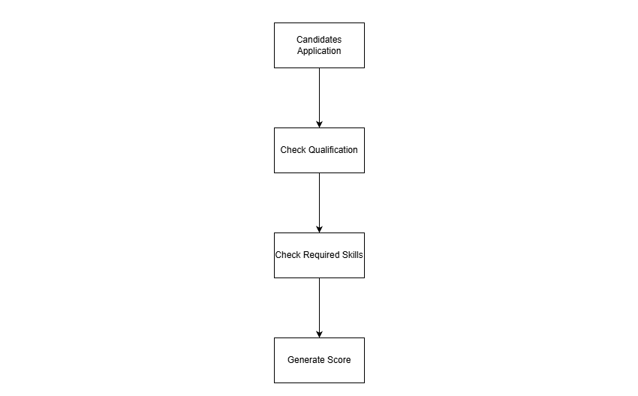
The diagram represents the process by which the AI system evaluates applicants’ step by step, based on certain recruitment rules. There is uniformity in the criteria used for hiring of all applicants.
Ontology-Based knowledge
Ontology-based knowledge assists the AI system to process the relationship between skills and qualifications, and between job roles and skills, rather than relying solely on exact keywords (Fernández Martínez et al., n.d., Robinson & Haendel, 2020).

Examples:
Software Development is related to programming languages.
“Project Management” relates to leadership and communication.
Data Analysis is related to statistics and visualization.

This enables the system to identify equivalent competencies if the candidates attempt to describe the same competencies differently in their resumes. It makes it more flexible and helps to avoid the unfair rejection of qualified applicants.
Ontology-based knowledge is particularly useful in multicultural contexts like Malaysia, where skills are often expressed in various ways.
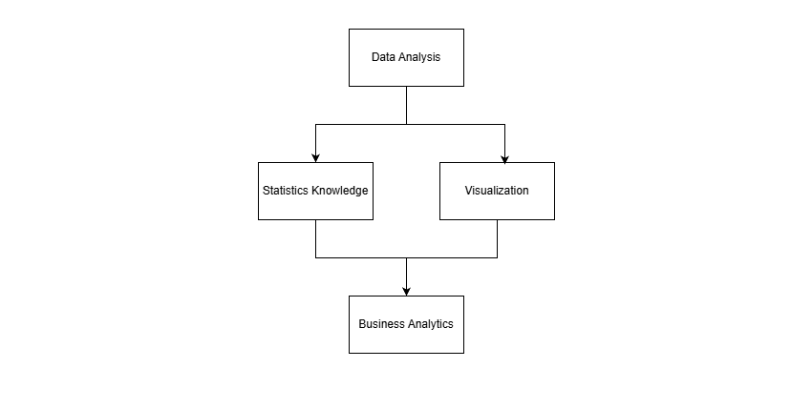
The diagram depicts the relationship between various skills and knowledge areas. This enables the AI system to learn about related competencies rather than just the specific words being used.

Probabilistic Knowledge
Recruitment is a decision-making process that is uncertain due to the possibility of future employee performance not being known with total accuracy. The probabilistic knowledge enables the AI system to make an educated guess on how likely candidates are to be successful in a specific job role (Gueddes & Mahjoub, 2023). The system can analyze multiple factors such as:
- Skills compatibility
- Work experience
- Assessment performance
- Interview scores
- Previous hiring outcomes
Based on these factors, the AI system generates suitability probabilities.
Example:
- Candidate A suitability score = 85%
- The suitability score of candidate B is 72%
This approach is a more flexible approach to decision making, since it does not rely on yes/no marking, but rather on the probability score.
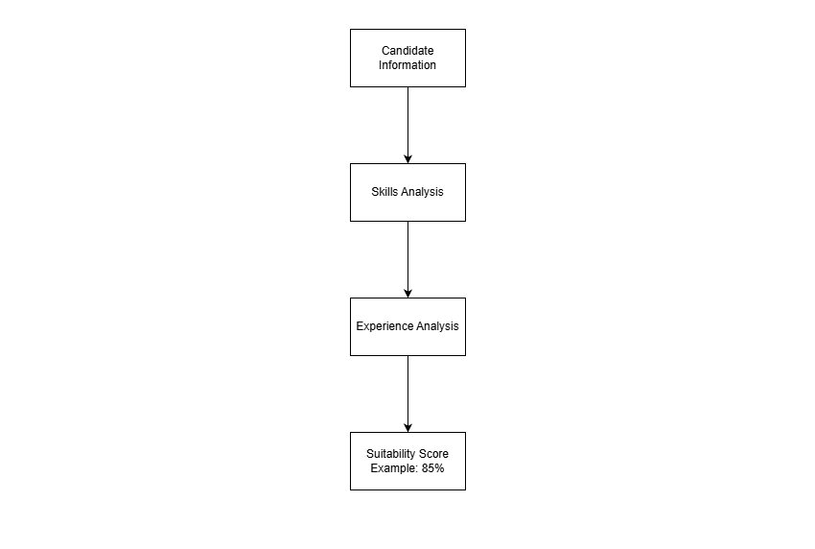
The diagram illustrates the process of how the information is processed by the AI system to calculate the suitability probabilities and assist in decision making in a situation where there is uncertainty.

Case-Based Knowledge
This case-based knowledge enables the AI system to learn from past recruitment experiences and the results of hiring. The system involves comparing new candidates to employees who have been successful in the past with similar backgrounds, skills and/or experience.
For example:
If you’re a successful software developer, you have likely exhibited problem-solving skills and teamwork.
Similar candidates may be recommended more highly.
This increases the efficiency of the recruitment process as the same experience can be used to assess new applicants.
But to minimize the risk of perpetuating past discrimination and/or bias, historical recruitment data should be reviewed on a regular bias
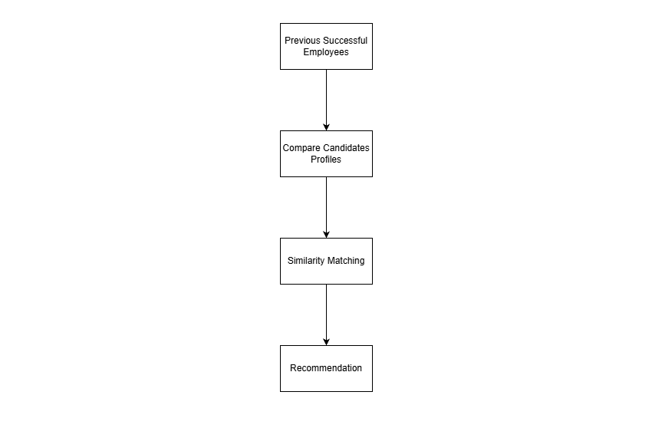
The diagram illustrates how the AI system will compare new applicants against previously successful recruitment cases for more accurate recommendations for future cases.
The use of several knowledge representations enhances the accuracy and fairness of the recruitment process. Rule-based knowledge ensures consistency as policies are applied to all candidates irrespective of them. By supporting the recognition of related skills and qualifications, Ontology-based knowledge brings down the strict dependency on keywords. The advantage of probabilistic knowledge is that it helps you make decisions when you don’t know what will happen in the future with respect to job performance, because that is never 100 percent certain. The system can learn from previous recruitment experience using case-based knowledge. These methods combine to form a more adaptable and ethical AI recruitment system.

2. Reasoning
The reasoning and planning component determines how the AI recruitment system evaluates candidates and supports hiring decisions. The proposed system uses probabilistic reasoning, human oversight, and ethical filtering to improve fairness, transparency, and accountability in recruitment.
Rule-Based Reasoning
The proposed system is based on rules and logic examining the conditions of the recruitment of candidates imposed by HR professionals and business rules (LinkedIn, 2026). To ensure that the system treats all candidates fairly.
The AI system monitoring the following:
- Minimum education level
- Required technical skills
- Work experience
- Professional certifications
For example, a job posting listed that they are looking for a three-year program background – the system would verify if the applicant had three years program experience or not. But a candidate who does not satisfy a requirement is not automatically disqualified. Rather, they may be flagged for human evaluation for reasons of fairness rather than being excluded from the program.
If there are fixed requirements in recruitment, the use of rule-based reasoning is appropriate. It enhances consistency, transparency and adherence to policies in the hiring process.
Probabilistic Reasoning
The proposed system is probabilistic that will decide in an uncertain situation. The AI system does not make a definitive yes/no call on whether someone will be successful in a particular role, but rather it provides a probability of success (Gueddes & Mahjoub, 2023).
The AI system considers:
- Skills match
- Work experience
- Assessment performance
- Interview results
The system creates suitability scores based on these factors.
Example:
- Candidate A suitability = 85%
- Candidate B suitability = 72%
This can help with more flexible recruitment decisions since they are made based on the probability score, rather than a fixed decision. The probability score can be revised as additional information about the candidates becomes available to increase the accuracy of the decision.

Human Oversight
One of the most important properties of the proposed system is human oversight. HR professionals make the ultimate decision while the AI system offers recommendations (Zhang et al., 2025).
Human recruitment review:
- AI-generated scores
- Candidate profiles
- Interview performance
- Ethical concerns
Recruitment can also manually choose to override the AI suggestions, if needed. This lowers automation bias, which is the danger for humans to blindly accept AI decisions critical examination. Human monitoring enhances accountability and guarantees recruitment decisions are context and fair.

Ethical filtering
In addition, the proposed system companies an ethical filtering mechanism which verifies for:
- Gender bias
- Racial bias
- Age discrimination
- Disability discrimination
The system automatically flags a decision for a human if unusual scoring patterns are found (Zhang et al., 2025). For example, when the women candidates stay at a lower score despite having the same qualifications, it triggers a fairness alert. This can help organizations detect underlying algorithmic bias and minimize unfair outcomes in recruiting.

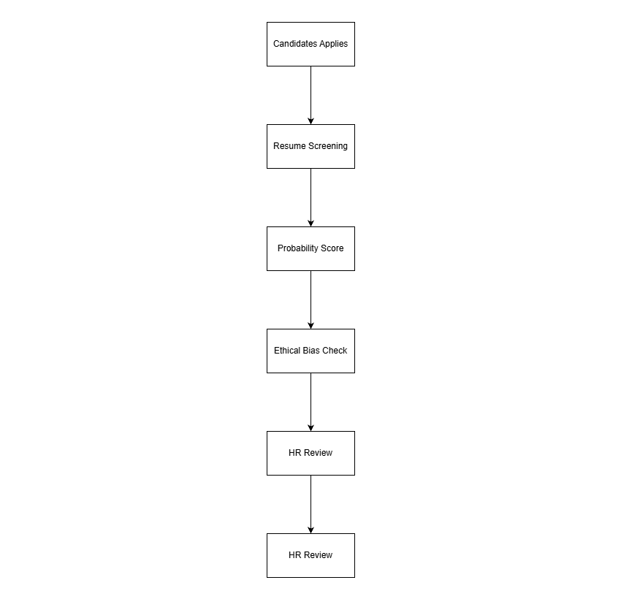

The proposed AI recruitment system’s overall reasoning and planning process is illustrated in the diagram above. The candidate information is probabilistically screened and evaluated in terms of suitability scores. The system then goes through an ethical filtering process to determine if the result may be biased or discriminatory, before it is presented to HR personnel for review. However, while there are human recruiters, the recruitment process is still transparency, accountable and fair.

3. Search and Inference Techniques
The AI recruitment system can efficiently identify potential candidates and make recommendations for recruitment using the search and inference techniques it utilizes. The significance of these techniques is such that when recruiting systems are required to handle huge quantities of applications, they need to be fair, transparent, and accurate in their decision-making process. The proposed system employs heuristic search, semantic search, Bayesian inference and decision tree inference to enhance the evaluation of candidates and guide ethical recruitment.

Heuristic Search
Heuristic search is commonly used in AI recruitment systems to efficiently rank suitable candidates from large applicant pools (Makhwana & Kale, 2026). With the AI system, candidates can be ranked according to key recruitment parameters including:
Skills relevance
Work experience
Educational background
Assessment background
This technique is adequate, as recruitment systems could have to process thousands of applications in a short period of time. Heuristic search will boost the effectiveness of search, by selecting the most suitable candidates, but still let HR review the final recommendations. It also cuts the workload and hastens the recruitment process (Makhwana & Kale, 2026).

Semantic Search
Semantic search enables the AI system to comprehend the meaning of the words rather than just matching them by their exact meaning.
For example:
“Software Engineering” may relate to Programming Development”
“Team Coordination” may relate to “Leadership Skills”
This process helps to minimize the risk of disqualifying suitable candidates as their language, educational background or work experience might convey their skills differently. In multicultural settings like Malaysia, candidates might employ various phrasings in their resumes and job applications, making semantic search particularly advantageous.
The system can recognize relationships among concepts and skills, which enables it to make more precise and flexible candidate matching (Robinson & Haendel, 2020).
Bayesian Inference
The AI system can update candidate suitability scores as additional data is fed back in, using Bayesian Inference.
Example:
Initial suitability score = 70%
After technical assessment = 82%
After interview = 88%
This technique is applicable because it is difficult to decide and the criteria for evaluating candidates evolve during the hiring process. This is the essence of Bayesian inference which enables the AI system to continually refine probability estimates as new candidate information because it is available.
Rather than taking the “one size fits all” approach at the beginning, the system changes its suggested outcomes as more assessment information and interview results are collected. This makes recruitment process more flexible and realistic (Pinto et al., 2025).
Bayesian inference allows the probability score to be continuously updated as new recruitment information becomes available (Pinto et al., 2025)

Decision Tree Inference
The decision tree inference makes the explanation clearer as HR professionals can see how the recommendations for recruiting are made.
Example:
IF Technical Skill is HIGH
AND communication = GOOD
THEN Recommend Candidate
ELSE Manual Review
This technique is appropriate since recruitment decisions should be transparent and understandable, particularly in the high stakes hiring process. HR staff will have access to the decision-making process of the AI system, as well as the reasons for the recommendation and flagging for their review.
In addition, the decision tree inference aids in holding the candidate accountable as recruitment decisions can be much better explained to both the employers and the candidates (Zhang et al., 2025).

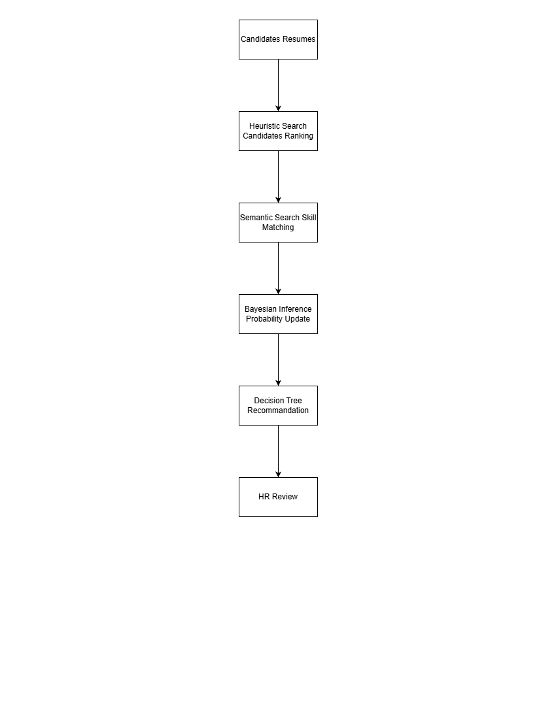
The diagram shows how different search and inference techniques work together in the AI recruitment system. Heuristic search efficiently ranks candidates; skill matching with semantics makes search more efficient; Bayesian inference updates the probability that a skill is suitable; and decision tree inference makes recommendations explainable. The final recommendation is then checked to see that the recruitment process is fair, accountable and transparent to HR personnel.

